Zentangle®. . .
. . . is an easy-to-learn, relaxing, fun art method to create beautiful images by drawing patterns inspired by our daily surroundings. Let go of ‘right or wrong’ to enjoy Zentangle for there is much more than drawing. Each person will express their Zentangle experiences differently as they slow down to put ink (pen), graphite (pencil) to paper.

Trained by the creators of the Zentangle Method, Rick Roberts and Maria Thomas,
Midori Okasako CZT (Certified Zentangle Teacher) will gently guide and support you while exploring the benefits and enjoyment of this universal, all embracing art process.

If you can write '• I C S O' you are ready to 'tangle. Rekindle and boost your creative confidence ‘one-stroke-at-a-time.’ In Zentangle there are ‘no mistakes, only new opportunities.

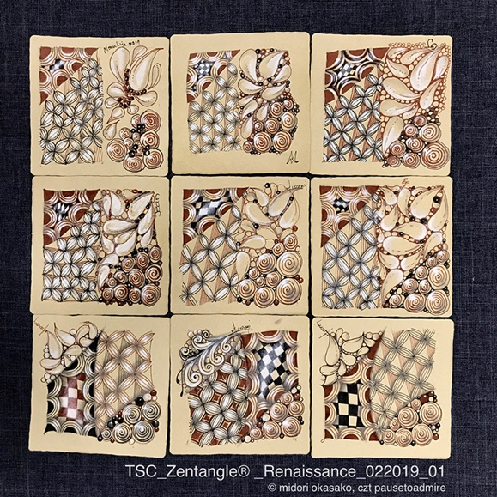

March, 2020_4-Week Zentangle® Tangle (Patterns) from the Past
Wednesdays_04, 11, 18, 25 (1:30 ~ 4:30 or 6:00 ~ 8:30)
Journey back in time and visit a variety of cultures, as you create beautiful ‘tangles’ (patterns) with Chiaroscuro (light & shade) with black & brown inks, graphite, white charcoal on ‘threaded’ and ‘woven’ white/ toned paper tiles. Slowly guided by core Zentangle 8-steps, unplug yourself to be inspired by everlasting universal, ornamental expressions.
(Prerequisite: Introductory Zentangle) (Maximum 10 Participants)

Art Supplies_ March, 2020_4-Week Zentangle Tangle Styles from the Past
Please purchase kit directly from instructor at session 01.
Please select your Option (1 or 2) for Official Zentangle Kit:
1) Complete Kit ($14.00) Assortment of White and Renaissance/Tan square and round paper tiles, Sakura 01 & 05 Brown, PN Black Pigma Microns, Graphite Pencil, General’s White Charcoal,
with Bonus_3 Blending Sticks and Sakura Gelly Roll Copper
2) Tiles Only Kit with Bonus_Sakura Gelly Roll Copper ($7.00)
Bring sketchbook or blank page notebook for note taking and tangle practices.
(Suggested: Strathmore 400 Series Drawing 6x8” 24 pages spiral bound.
Available directly from instructor $3.00 or from art & craft supply stores for $6.00±.

Midori Okasako, CZT may be emailed for specific questions regarding Zentangle class or supplies: m.pausetoadmire@gmail.com
For information regarding your registration or payment,
please contact TSC Art Coordinator Jennifer.Haskins@talgov.com or call 891-401

